Assignment (08/05/2020)

1. Identify the OSI reference model layer for each of the following concepts.

CSMA/CD – Physical Layer
Manchester encoding – Physical Layer
Internet Protocol – Network Layer
HTTP – Application Layer

2. What key improvement did Ethernet make over Aloha?
Ans. The key improvement was a mechanism that detected when a collision occurred (collision detection). The system also included “listen before talk,” in which stations listened for activity (carrier sense) before transmitting, and supported access to a shared channel by multiple stations (multiple access). Aloha could achieve a maximum channel utilization of about 37%, due to the rapidly increasing rate of collisions under increasing load whereas ethernet developed a more sophisticated backoff algorithm, which, in combination with the CSMA/CD protocol, allowed the Ethernet system to function at up to 100% load.

3. Compare how exponential backoff is used in CSMA/CD versus CSMA/CA. Briefly
describe how the exponential backoff algorithm works.
Ans. CSMA/CD uses exponential backoff after a collision is detected. If a collision occurs after 2 hosts try to transmit, hosts wait some time (determined by exp backoff) and then try transmitting again.
CSMA/CA uses exponential backoff before a collision occurs (in an attempt to avoid collisions completely). When a collision is inferred, hosts wait for some number of idle timeslots (determined by exp backoff) to pass before trying to listen again.
Working of Exponential backoff:
Used to schedule retransmissions after collisions.
After c collisions, a random number of slot times between 0 and 2^c − 1 is chosen. i.e After the first collision, each sender will wait 0 or 1 slot times. After the second collision, the senders will wait anywhere from 0 to 3 slot times (inclusive). After the third collision, the senders will wait anywhere from 0 to 7 slot times (inclusive), and so forth.
As the number of retransmission attempts increases, the number of possibilities for delay increases exponentially.
4. A host receives the following bit message: 11010110111110. Assume the sending and receiving hosts agreed in advance to use the same CRC polynomial: x⁴ + x + 1.
a. What is the degree of the CRC polynomial?
Ans. Degree : 4
b. Which bits of the bit message correspond to data and which bits correspond to the CRC checksum?
Ans. Binary pattern for the given CRC generator: 10011
Number of bits (n) : 5
When the message is divided by the number 10011
Data : 1101011011
CRC checksum added: 1110

c. Was there an error in the transmission of this bit message? Show your work.
Ans. There is no error in the transmission :

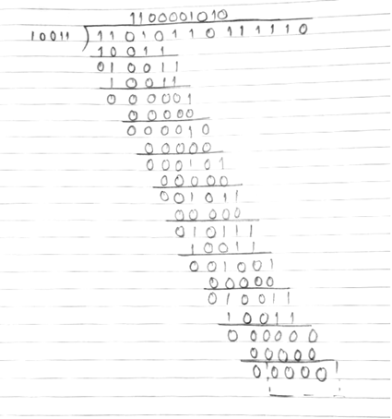
5. Compare Aloha and Slotted Aloha.
Ans.

Key | Aloha | Slotted Aloha
Time Slot | In Pure Aloha, any station can transmit data at any time. | In Slotted Aloha, any station can transmit data only at beginning of any time slot.
Time | In Pure Aloha, time is continous and is not globally syncronized. | In Slotted Aloha, time is discrete and is globally syncronized.
Vulnerable time | Vulnerable time = 2 x Tt. | Vulnerable time = Tt.
Probability | Probability of successful transmission of data packet = G x e^{-2G} | Probability of successful transmission of data packet = G x e^{-G}
Maximum efficiency | Maximum efficiency = 18.4%. | Maximum efficiency = 36.8%.
Number of collisions | Does to reduces the number of collisions. | Slotted Aloha reduces the number of collisions to half thus doubles the efficiency.

